PART:01
When you use the man page of any command:
Man nmap
After that Then to search any flag/switch you have to write (/ flag--switch) to seach that aand press “n” to move to next available.

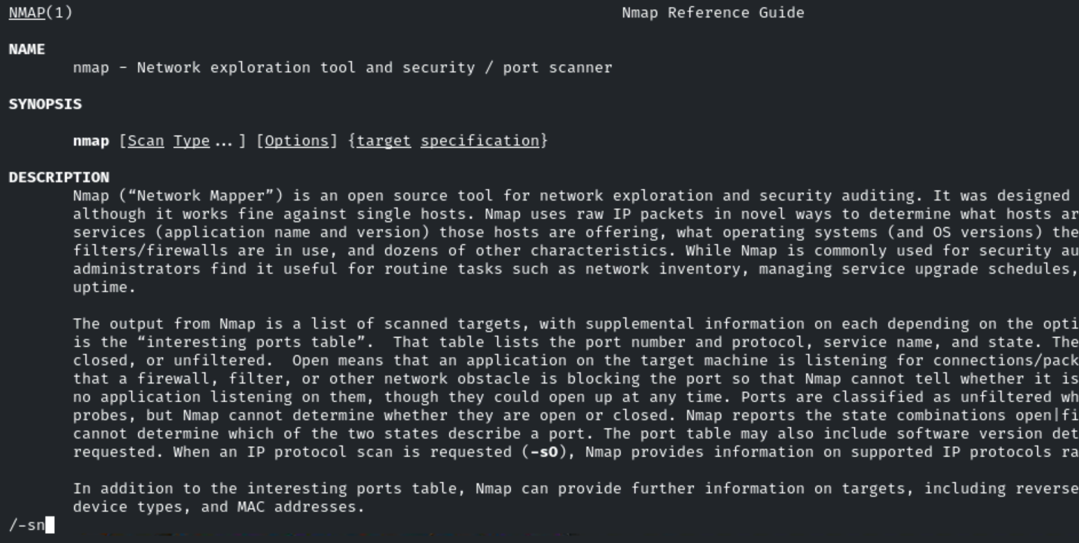

Nmap -sn ip-address - - send-ip
Note:
By default, when scanning targets on your local subnet, Nmap uses ARP (Address Resolution Protocol) for host discovery
But if you use --send-ip, Nmap will:
- Avoid ARP, and
- Send regular IP packets (like ICMP Echo or TCP pings),
- Just like it would for scanning hosts outside your local network.

To scan the range of ips
Nmap -sn 192.168.1.0/24
OR
Nmap -sn 192.168.1.0-100
It will scan the 0 to 100 ip’s in that network.

To scan more then one ip address we can use the
Nmap -sn 192.168.1.1 192.168.1.99

PART:02
In pen testing there is typically a target list.
To scan the list of ip :
Nmap -sn -iL target.txt

Tcp SYN ping :

Syn flag set:
Nmap -sn -PS ip-address
If it doesnot receive the response then it does not means that the target is not live but their may be presence of the firewall.

Recommended:
Nmap -sn -PS1-1000 ip-address

Nmap -sn -PS1,10,445,600 ip-address
Don’t recommended:
Tcp ACK ping:
It can also used to check the firewall is in place If the host is up.

Nmap -sn -PA ip-address

Nmap -sn -PA3389 ip-address

Only icmp check:
Nmap -sn -PE ip-address //icmp host discovery echo request (PE)

Nmap -sn -PN ip-address –send-ip //For local ethernet network.

Teacher choice:
Ping scan //for general
Tcp syn ping scan after it.

Command:
Nmap -sn -v -T4 ip-address

Nmap -sn -PS21,22,25,80,445,3389,8080 -T4 ip-address

For window:
Nmap -sn -PS21,22,25,80,445,3389,8080 -T4 -PU137,138 ip-address

Net-bios run on udp.

